***General Instruction***

* ***Please use unity version 2021.3.3f1 for assignment development preferably.***
* ***Please upload the complete project solution on one drive on completion of the assignment and share the link for download.***

**Assignment to create a prototype**

A slot game comprises different streams of works

* Game concept
* Art/Animations/sounds
* Maths
* Engineering

We expect you to be an expert in engineering and for the rest of the competency you can take dummy assets from the web.

**Game concept:**

Task Description:

* create an interface/UI that look like this

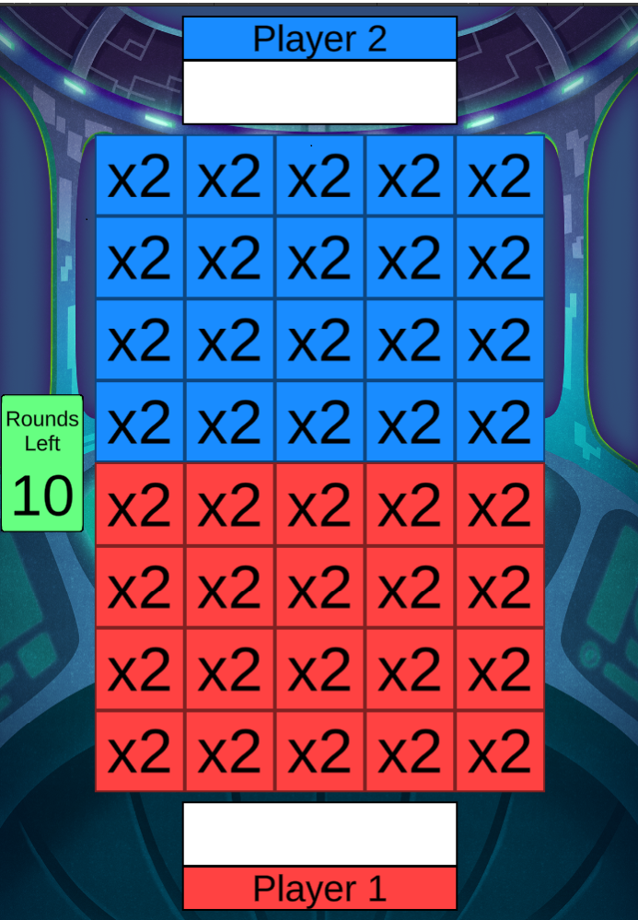

* Description about game play
  + This is a 2 player’s ,Red(Player 1) and Blue(Player 2) bonus feature.
  + Total 10 bonus rounds are played . The game round count is decremented by 1 on each bonus round. The game ends when rounds left are zero.The Player’s take turn’s to decide their outcome in a game round. Any Player can start the game.
  + All the rounds are played on an Auto Play mode i.e there is no user interaction required. The Player’s are nothing but bots.
  + The first round is initiated as soon as the game is launched and the next round is automatically initiated once a round is complete.
  + Each player controls a 4X5 grid to start off. Each 1X1 zone in the grid is initialised with a default score of 2 depicted as x2.
  + Each bonus round consists of an outcome for each player. Each outcome gives either a BLANK/STEAL/BOOST/SHIELD that affects the game in some way described below. Outcome for Player 1 is evaluated first followed by the Player 2's outcome ,one at a time.
  + The result/outcome of each team's is determined by the chance or probability as defined below. Players 1 and 2 use the same chance/probability.
  + The different types of outcomes possible are BLANK, STEAL, BOOST and SHIELD. Below is the chance/probability of occurrence for each outcome.
    - BLANK has 35% chance
    - STEAL have 25% chance
    - BOOST has 30% chance
    - SHIELD has 10 % chance
* Description about each outcome:
  + **STEAL**

A Steal outcome will take control of 2 random zones that are currently controlled by the opposite player.

If the number of zones to be stolen outnumbers the zones currently controlled by the other team, then excess STEALs are ignored or If the team controls the entire grid, then the steal is ignored.

If a shielded zone is selected for steel operation then the shield is removed.The zone is available for Steal from the next round.

* + **BOOST**

A Boost outcome will increase/boost the value of 3 random zones that the player controls. The boost amount is an integer value which is multiplied with the score assigned currently with that zone. Below is the chance/probability associated with each of the boost amounts. For a single boost operation ,the boost amount is picked 3 times( for each zone).

* + - 2 has 35% chance
    - 3 have 30% chance
    - 5 has 25% chance
    - 10 has 10 % chance

If the number of zones to be boosted outnumbers the zones currently controlled by the team, then excess boosts are ignored.

* + **SHIELD**

A Shield outcome will shield 2 random zones that are currently controlled by the player.Shield prevents the zones from STEAL action from the opposing player. If the number of zones to be shielded outnumbers the zones currently controlled by the team, then excess shields are ignored.

If an already shielded zone is selected for shield then it is ignored however the shielded zone can be boosted.  
 If a shielded zone is selected for steal action then the shield breaks and it is available for steal in the next round.

* + **BLANK**

No Action is performed.

* When no more bonus rounds remain, the player that controls the most number of zones is declared the winner.
* If both players control the same number of zones, then the team with the highest score is declared the winner.
* A banner is displayed showing the winner and the total score .
* Outcomes for each bot should be displayed in the blank space above the player text.

**Art/Animations/sounds:** you can choose any art you want from your previously created portfolio or use anything from the web and same for sounds.

**Engineering:**

Please use unity engine to build this prototype game and use C# programming language as used with unity to build game play.